Linux Programming : Assignment-6
Name : Vigneshwaran P
Class:3C
USN : ENG24CY0069

- Which command is used to list the contents of a directory? Justify with proper example.
Soln:
ls
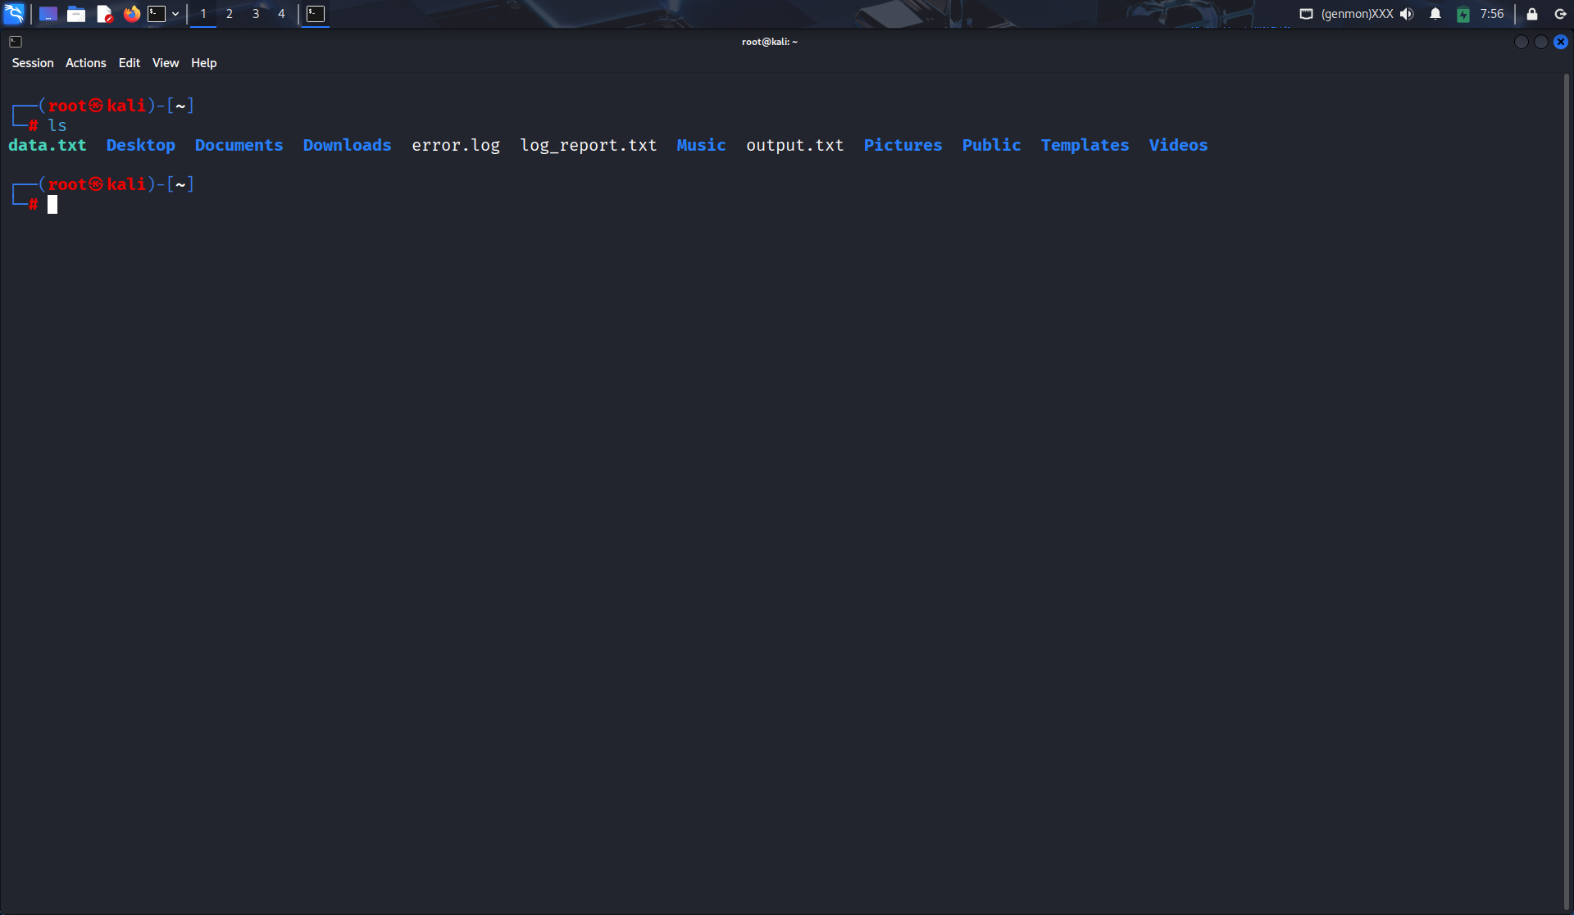

- Write the command to create a new directory named 123test_dir.
Soln:
mkdir 123test_dir
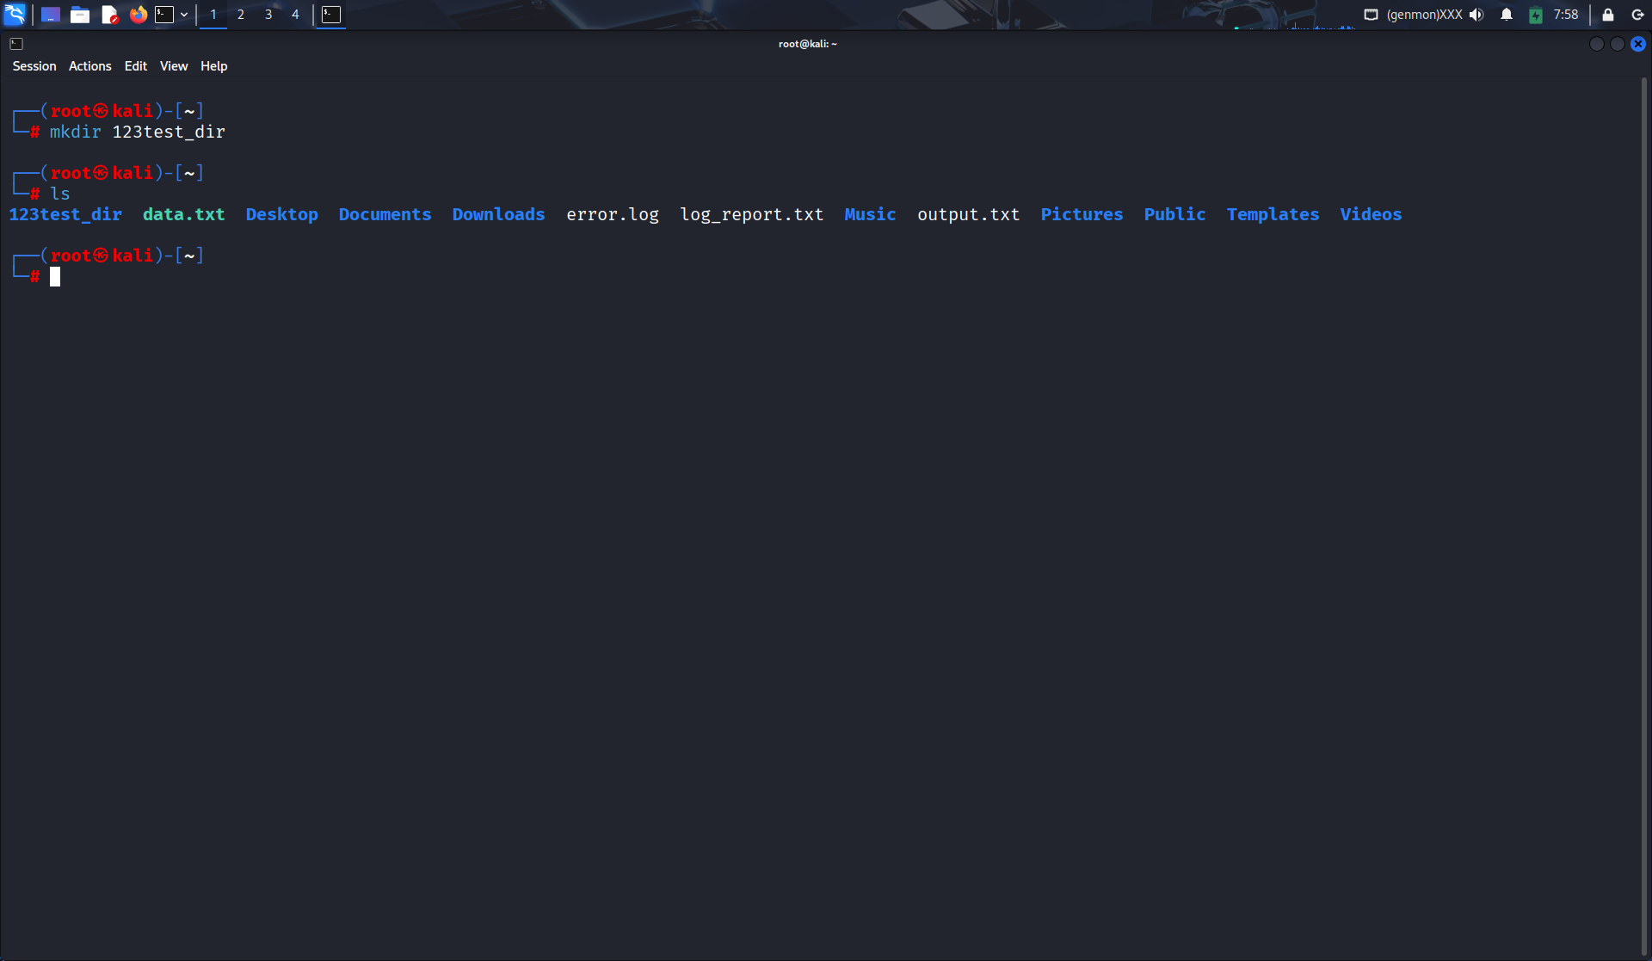
3. What is the purpose of the sed command? Justify with proper example.
Soln:
sed is a stream editor used for find-and-replace or text manipulation.
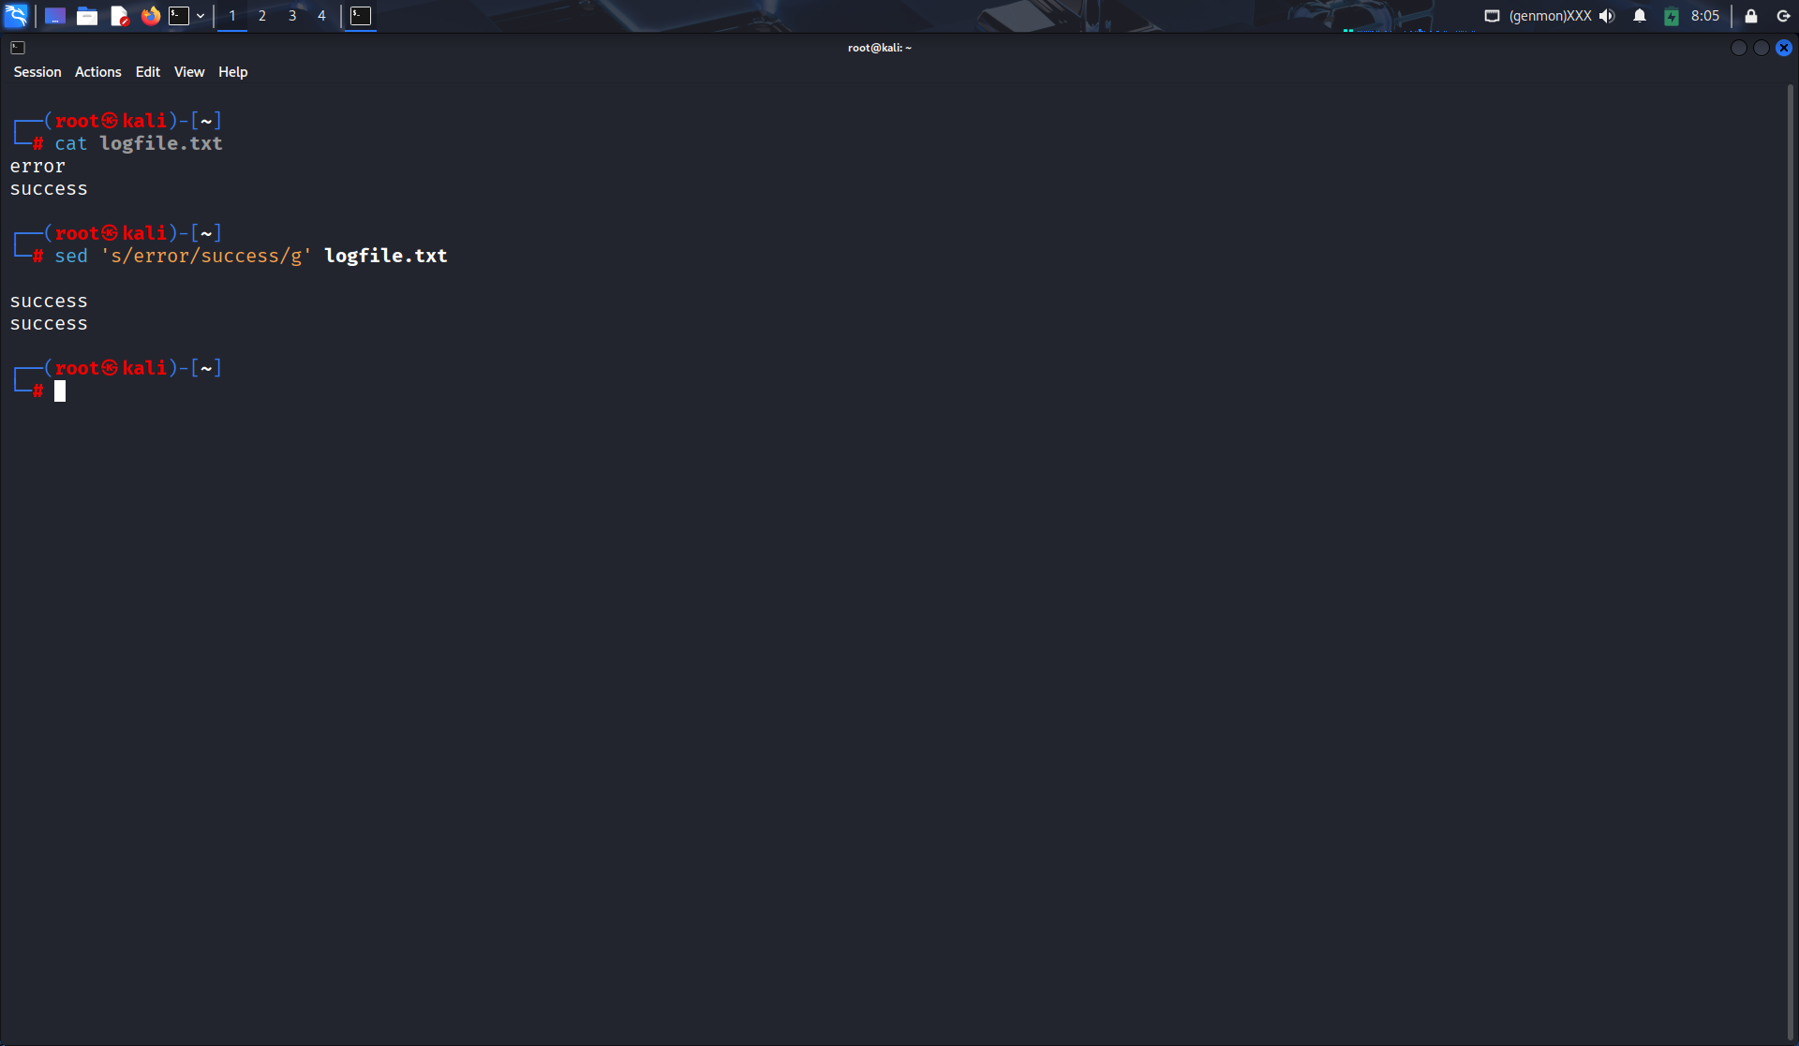

4. Which distinct command is used to display one-line descriptions of any commands?
Soln:
whatis
Ex:
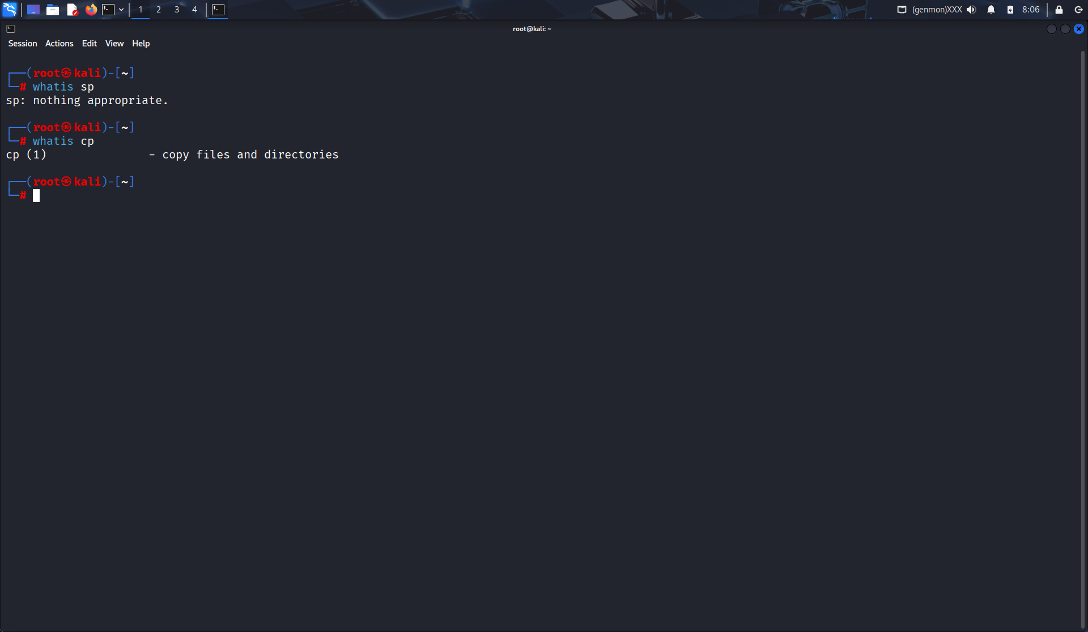

5. Write the command to create an empty file named “notes.txt”.
Soln:
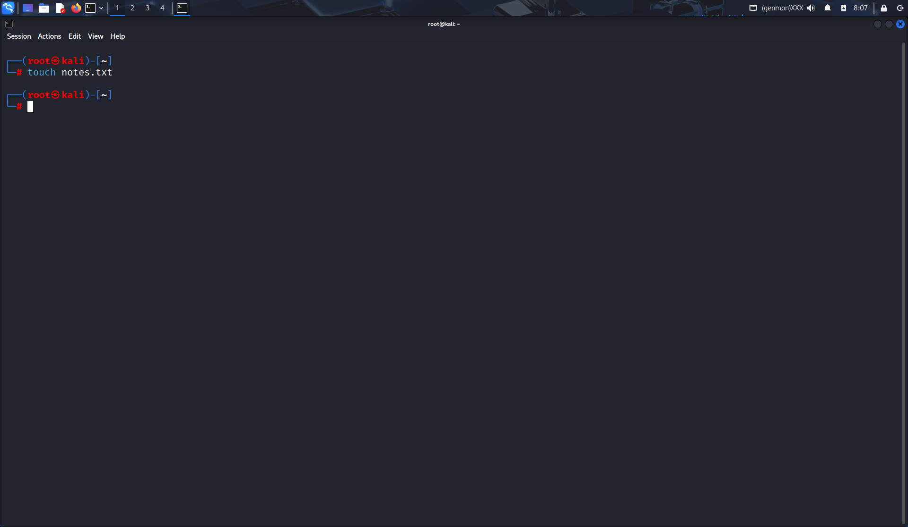
6. Differentiate between grep and awk commands with an example.
Soln:
grep searches for patterns in text.
awk processes and formats text based on patterns.
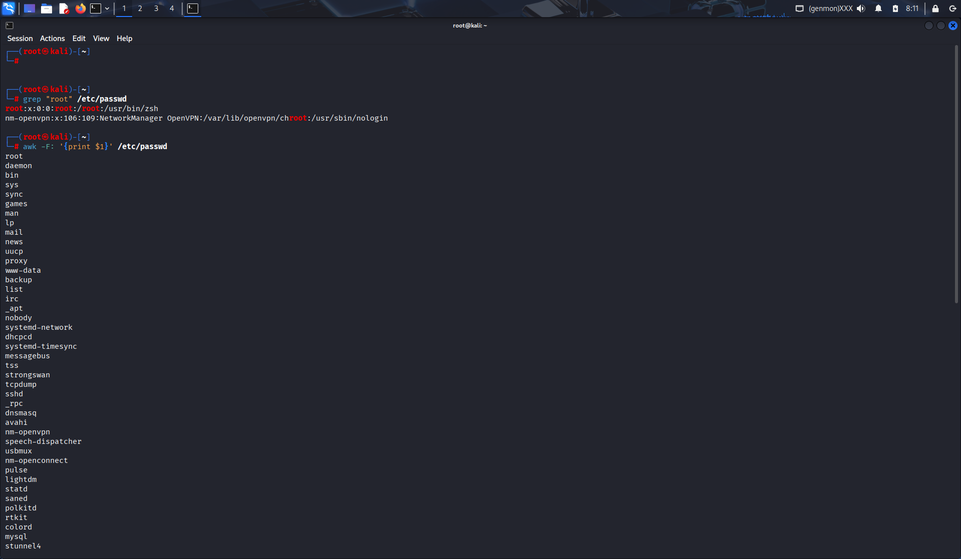

7. Write the command to give read, write, and execute permission to the owner of a file script.sh.
Soln:
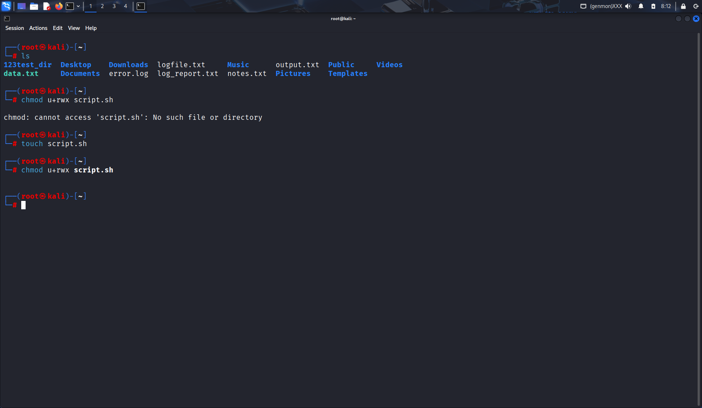

8. How is chown different from chgrp? Give one example for each.
Soln:
chown → change owner.
chgrp → change group.
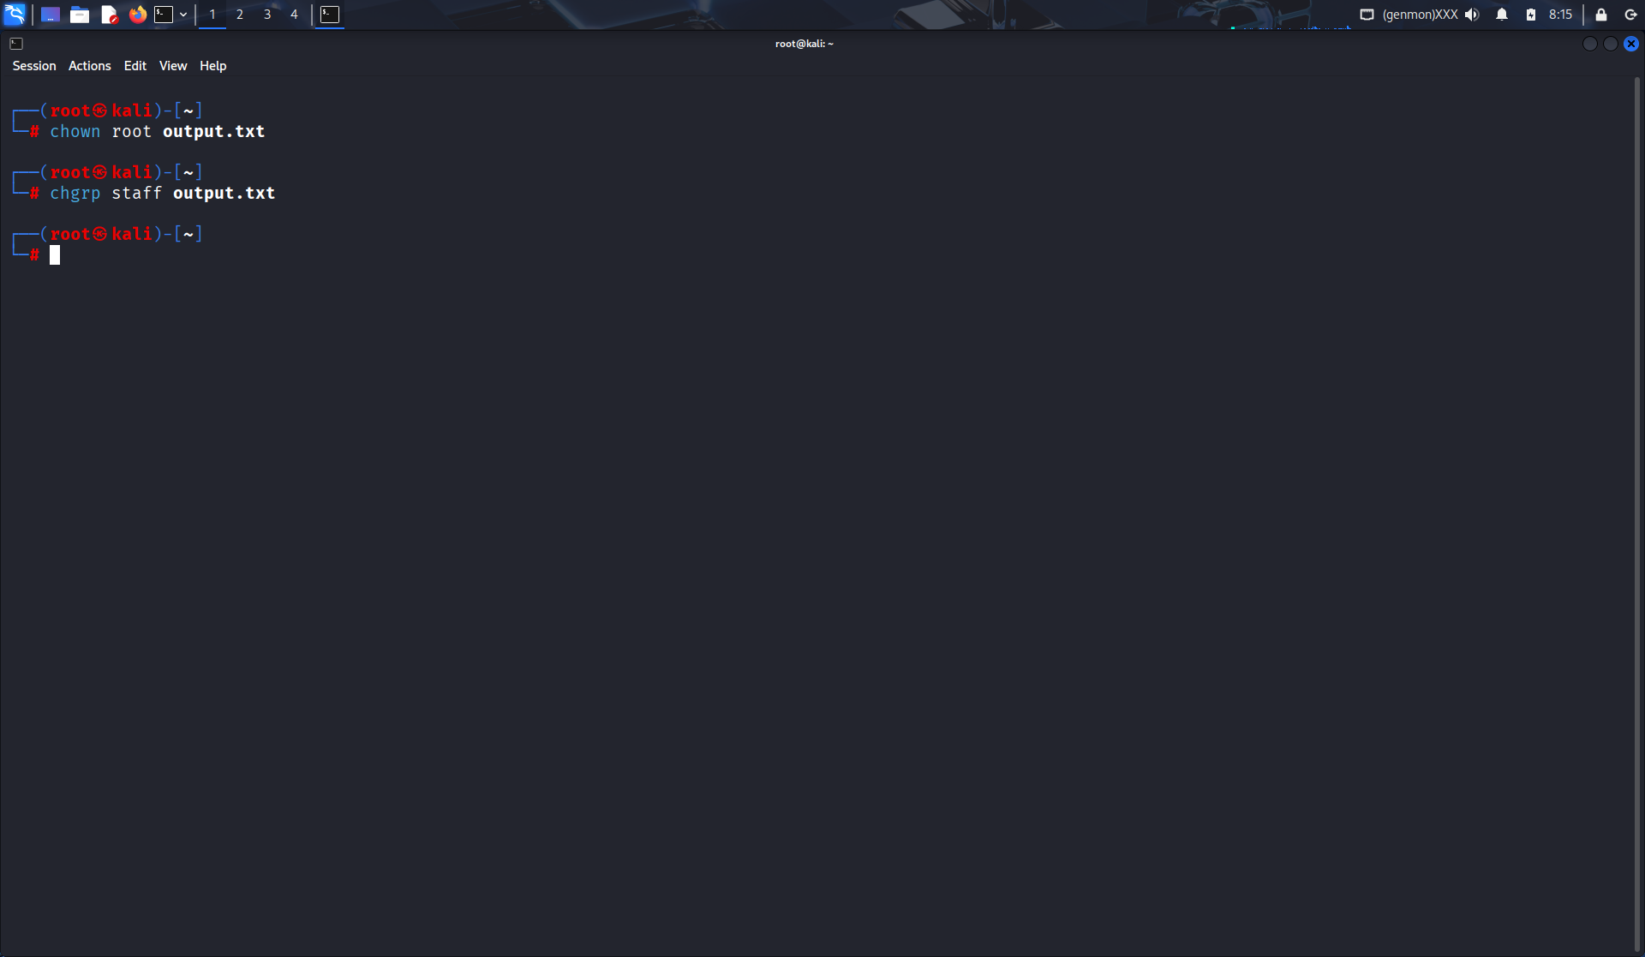

9. A user complains that they cannot execute a file even though it exists in their directory. How would you troubleshoot this using ls -l, chmod, and whoami?
Soln:
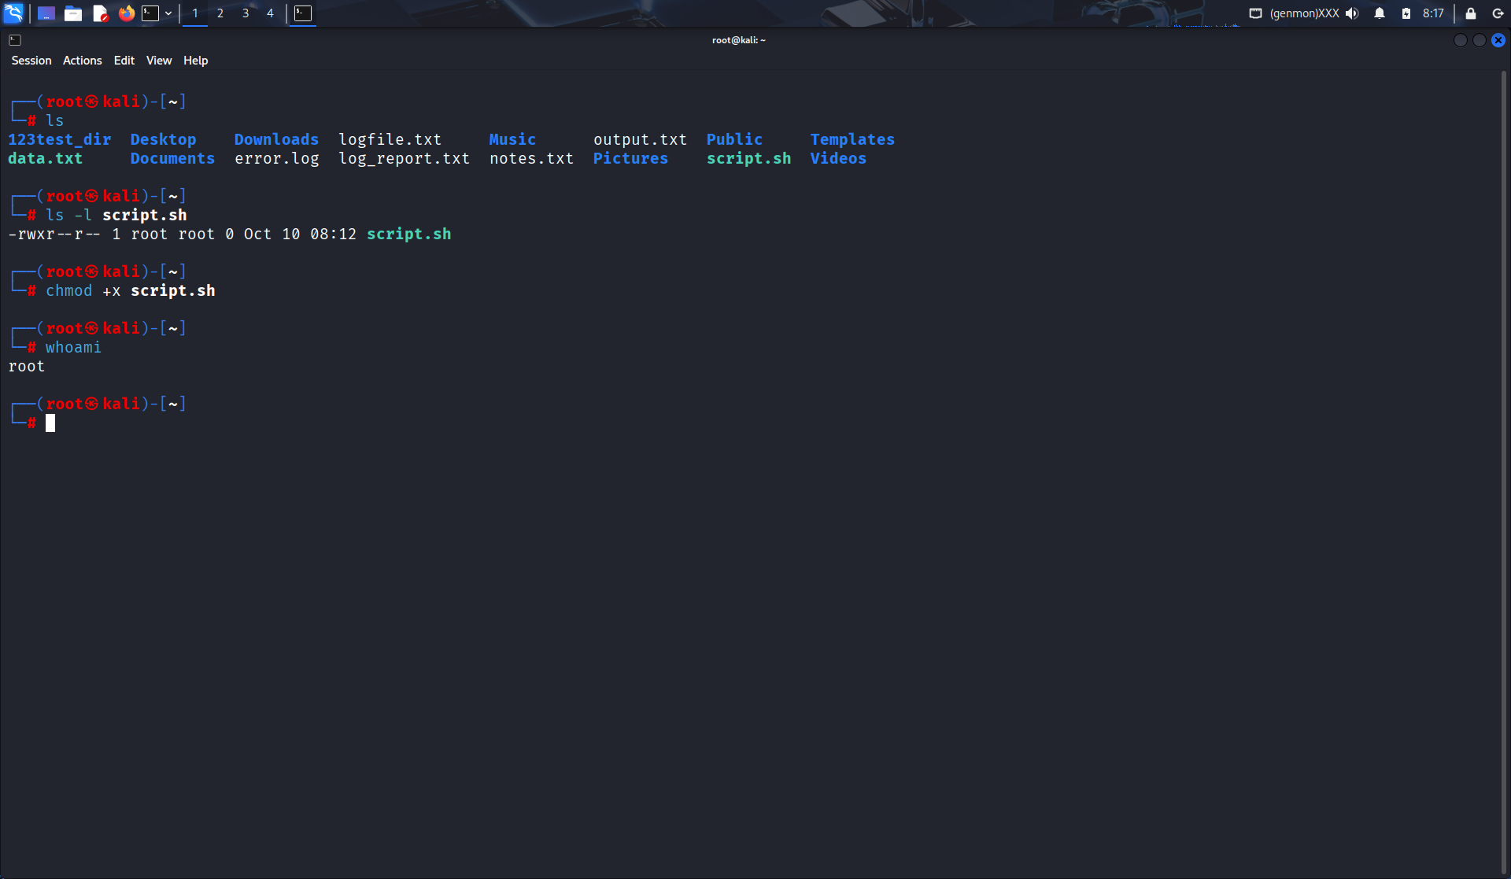

10. Design a command pipeline to: find all .log files modified in the last 2 days in /var/log, display them on screen, and save the results into a file recent_logs.txt using tee command.
Soln:
